Q1.
The diagram below shows a cyclist riding along a flat road.
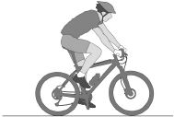
(a) Complete the sentence.
Choose answers from the box.

chemical | elastic potential | gravitational potential | kinetic
As the cyclist accelerates, the _______________________ energy store in
the cyclist’s body decreases and the _______________________ energy of
the cyclist increases.
(2)
(b) The mass of the cyclist is 80 kg. The speed of the cyclist is 12 m/s.
Calculate the kinetic energy of the cyclist.
Use the equation:
kinetic energy = 0.5 × mass × (speed)²
___________________________________________________________________
___________________________________________________________________
___________________________________________________________________
___________________________________________________________________
Kinetic energy = ______________________ J
(2)
(c) When the cyclist uses the brakes, the bicycle slows down.
This causes the temperature of the brake pads to increase by 50 °C.
The mass of the brake pads is 0.040 kg.
The specific heat capacity of the material of the brake pads is 480 J/kg °C.
Calculate the change in thermal energy of the brake pads.
Use the equation:
change in thermal energy = mass × specific heat capacity × temperature change
___________________________________________________________________
___________________________________________________________________
___________________________________________________________________
Change in thermal energy = ______________________ J
(2)
(d) How is the internal energy of the particles in the brake pads affected by the increase in temperature?
Tick one box.

Decreased | 
Increased
Not affected
(1)
(Total 7 marks)
Q2.
The figure shows a boy bouncing on a trampoline.
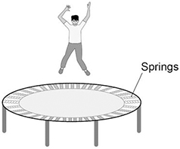
(a) The boy falls from the position in the figure above towards the trampoline.
Complete the sentences.
Choose answers from the box.

chemical |  | elastic potential |  | gravitational potential
 | kinetic |  | nuclear
As the boy falls, there is a decrease in his _______________ energy.
As the boy falls, there is an increase in his ______________ energy.
(2)
(b) As the boy lands on the trampoline, each spring stretches 0.015 m.
spring constant of each spring = 120 000 N/m
Calculate the energy stored by each spring.
Use the equation:
elastic potential energy = 0.5 × spring constant × (extension)²
___________________________________________________________________
___________________________________________________________________
___________________________________________________________________
Elastic potential energy = _______________ J
(2)
(c) There are 40 springs on the trampoline.
Calculate the total energy stored by the 40 springs when each spring is stretched by 0.015 m.
Use your answer from part (b)
___________________________________________________________________
___________________________________________________________________
Total energy stored = _______________ J
(1)
(d) The kinetic energy of the boy as he lands on the trampoline is 600 J.
The maximum kinetic energy of the boy after he bounces is 45% of his kinetic energy as he lands.
Calculate the maximum kinetic energy of the boy after he bounces.
___________________________________________________________________
___________________________________________________________________
___________________________________________________________________
Maximum kinetic energy = _______________ J
(2)
(e) Why is the kinetic energy of the boy after he bounces less than his kinetic energy as he lands?
Tick (✓) one box.

Energy is not conserved. | 
Energy is transferred to the surroundings.
The springs transfer energy to the boy.
(1)
(Total 8 marks)
Q3.
A student heated water in an electric kettle.
(a) Water has a high specific heat capacity.
Complete the sentence.
Choose answers from the box.

°C | J | kg | s | W
The specific heat capacity of a substance is the energy needed to raise the
temperature of 1 __________ of the substance by 1 __________.
(2)
(b) The kettle circuit contains a thermistor which is used to switch the kettle off when the water reaches 100 °C.
What is the correct symbol for a thermistor?
Tick (✓) one box.

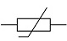 |  | 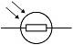
(1)
(c) The resistance of the heating element in the kettle is 15 Ω.
The current in the heating element is 12 A.
Calculate the power of the heating element.
Use the equation:
power = (current)² × resistance
___________________________________________________________________
___________________________________________________________________
___________________________________________________________________
___________________________________________________________________
___________________________________________________________________
Power = _______________ W
(2)
The student investigated how quickly the kettle could increase the temperature of 0.50 kg of water.
The graph below shows the results of the investigation.
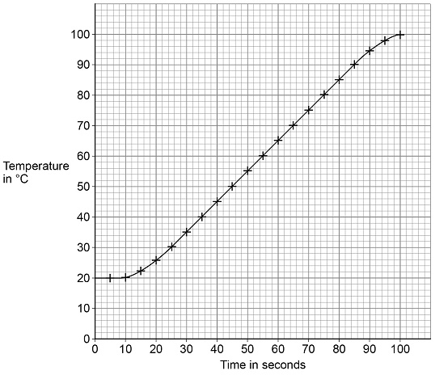
(d) The temperature of the water did not start to increase until 10 seconds after the kettle was switched on.
What is the reason for this?
Tick (✓) one box.

Energy is transferred from the surroundings to the kettle.
The charge flows slowly through the kettle circuit.
The heating element in the kettle takes time to heat up.
The power output of the kettle increases slowly.
(1)
(e) Describe a method the student could have used to obtain the results shown in the graph.
___________________________________________________________________
___________________________________________________________________
___________________________________________________________________
___________________________________________________________________
___________________________________________________________________
___________________________________________________________________
___________________________________________________________________
___________________________________________________________________
___________________________________________________________________
___________________________________________________________________
___________________________________________________________________
___________________________________________________________________
(6)
(f) The mass of water in the kettle was 0.50 kg.
The temperature of the water increased from 20 °C to 100 °C.
specific heat capacity of water = 4200 J/kg/°C
Calculate the energy transferred to the water.
Use the Physics Equations Sheet.
___________________________________________________________________
___________________________________________________________________
___________________________________________________________________
___________________________________________________________________
___________________________________________________________________
Energy = _______________ J
(3)
(g) The water in the kettle boiled for a short time before the kettle switched off.
During this time 5.0 g of water changed to steam.
specific latent heat of vaporisation of water = 2 260 000 J/kg
Calculate the energy transferred to change the water to steam.
Use the Physics Equations Sheet.
___________________________________________________________________
___________________________________________________________________
___________________________________________________________________
___________________________________________________________________
___________________________________________________________________
Energy = _______________ J
(3)
(Total 18 marks)
Q4.
The photograph below shows a theme park ride called AquaShute.
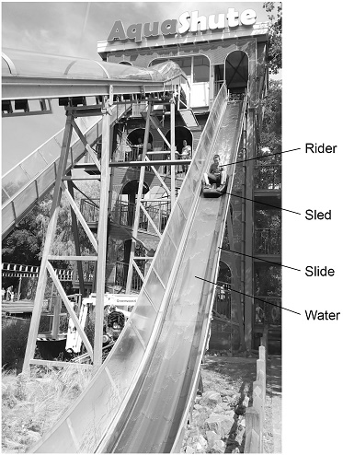
(a) Riders of the AquaShute sit on a sled and move down a slide.
There is a layer of water between the sled and the slide.
How does the layer of water affect the friction between the sled and the slide?
Tick (✓) one box.

The friction is decreased.
The friction is increased.
The friction is not affected.
(1)
(b) The mass of one rider is 62.5 kg.
The height of the slide is 16.0 m.
gravitational field strength = 9.8 N/kg
Calculate the gravitational potential energy of the rider at the top of the slide.
Use the equation:
gravitational potential energy = mass × gravitational field strength × height
___________________________________________________________________
___________________________________________________________________
___________________________________________________________________
___________________________________________________________________
Gravitational potential energy = _______________ J
(2)
(c) At the bottom of the slide the speed of the rider is 12 m/s.
The mass of the rider is 62.5 kg.
Calculate the kinetic energy of the rider at the bottom of the slide.
Use the equation:
kinetic energy = 0.5 × mass × (speed)²
___________________________________________________________________
___________________________________________________________________
___________________________________________________________________
___________________________________________________________________
Kinetic energy = _______________ J
(2)
(d) When a rider reaches the bottom of the slide, the sled decelerates and stops.
Give two factors that will affect how far the sled will move before it stops.
1 _________________________________________________________________
___________________________________________________________________
2 _________________________________________________________________
___________________________________________________________________
(2)
(Total 7 marks)
Q5.
The figure below shows a diver about to dive off a diving board.
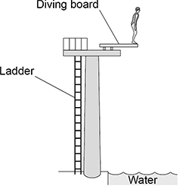
(a) Complete the sentences.
Choose answers from the box.

elastic potential | gravitational potential | kinetic | nuclear
As the diver falls towards the water there is a decrease in
her _____________________________________ energy.
As the diver falls towards the water there is an increase in
her _____________________________________ energy.
(2)
(b) Write down the equation which links kinetic energy (E_{k}), mass (m) and speed (v).
___________________________________________________________________
(1)
(c) At the instant the diver hits the water, the kinetic energy of the diver is 5040 J.
The speed of the diver is 12 m/s.
Calculate the mass of the diver.
___________________________________________________________________
___________________________________________________________________
___________________________________________________________________
___________________________________________________________________
Mass = _______________ kg
(3)
(d) Most of the kinetic energy of the diver is transferred to the water.
How does this affect the thermal energy of the water?
Tick (✓) one box.

The thermal energy decreases.
The thermal energy stays the same.
The thermal energy increases.
(1)
(Total 7 marks)
Q6.
A student uses an electric motor to lift a load.
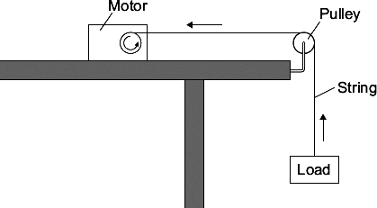
In the motor, the electrical energy is transferred into other types of energy. Some of this energy is useful and the rest of the energy is wasted.
(a) (i) Name the useful energy output from the electric motor.
______________________________________________________________
(1)
(ii) What eventually happens to the wasted energy?
______________________________________________________________
______________________________________________________________
(1)
(b) The graph shows the input energy the motor needs to lift different loads by one metre.
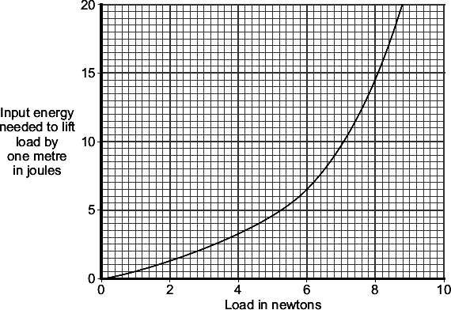
What can you conclude from the graph about the relationship between the load lifted and the input energy needed?
___________________________________________________________________
___________________________________________________________________
___________________________________________________________________
___________________________________________________________________
(2)

(c) | A shop uses escalators to lift customers to different floor levels. The escalators use electric motors. When the shop is not busy some escalators are turned off. A sign tells the customers that the escalators are turned off to save energy. | 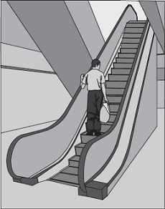
(i) Each escalator has one motor with an average power of 4000 W. The motor is turned on for an average of 8 hours each day, 6 days each week. Electricity costs 15 pence per kilowatt-hour.
Calculate the cost of the electricity used in an average week to run one escalator.
Show clearly how you work out your answer.
______________________________________________________________
______________________________________________________________
______________________________________________________________
______________________________________________________________
Cost = _______________________ pence
(3)
(ii) Give one environmental advantage to turning off electrical appliances when they are not being used.
______________________________________________________________
______________________________________________________________
(1)
(Total 8 marks)
Q7.
A child drops a ball.
The ball hits the ground and bounces.
The graph below shows the velocity-time graph for the ball from when the ball is dropped until when the ball reaches the top of its first bounce.
Air resistance has been ignored.
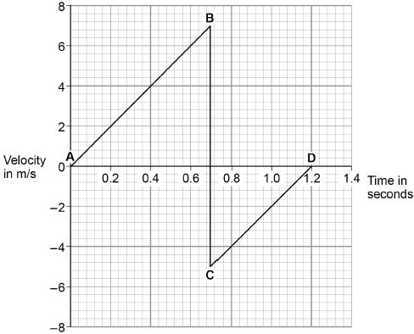
(a) Describe the motion of the ball between points A and B on the graph above.
___________________________________________________________________
___________________________________________________________________
___________________________________________________________________
___________________________________________________________________
(2)
(b) What direction is the ball moving between points C and D on the graph above?
___________________________________________________________________
(1)
(c) The ball and the Earth form a system.
What is meant by ‘a system’?
Tick one box.

A group of objects that interact.
Objects with big differences in mass.
Objects with gravitational potential energy.
(1)
(d) When the ball hits the ground, energy is transferred from the ball to the Earth.
Explain how the data in the graph above shows this energy transfer.
___________________________________________________________________
___________________________________________________________________
___________________________________________________________________
___________________________________________________________________
___________________________________________________________________
___________________________________________________________________
___________________________________________________________________
___________________________________________________________________
___________________________________________________________________
___________________________________________________________________
(4)
(Total 8 marks)
Q8.
The image shows a battery-powered drone.
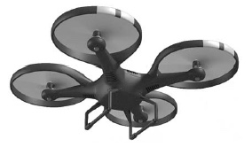
(a) Complete the sentences.
Choose the answers from the box.

 | chemical | elastic potential
gravitational potential |  | kinetic | nuclear
As the drone accelerates upwards
its _________________________________________ energy increases
and its _________________________________________ energy increases.
The _________________________________________ energy store
of the battery decreases.
(3)
(b) In the USA, drones are not allowed to be flown too high above the ground.
Suggest one possible risk of flying a drone too high above the ground.
___________________________________________________________________
___________________________________________________________________
___________________________________________________________________
(2)
(c) Write down the equation that links energy transferred, power and time.
___________________________________________________________________
(1)
(d) The drone can fly for 25 minutes before the battery needs recharging.
The power output of the battery is 65.0 W
Calculate the maximum energy stored by the battery.
___________________________________________________________________
___________________________________________________________________
___________________________________________________________________
___________________________________________________________________
Maximum energy = ____________________ joules
(3)
(Total 8 marks)
Q9.
A baby bouncer is a harness attached to a spring that hangs from a door frame.
The figure above shows a baby in a baby bouncer in two positions.
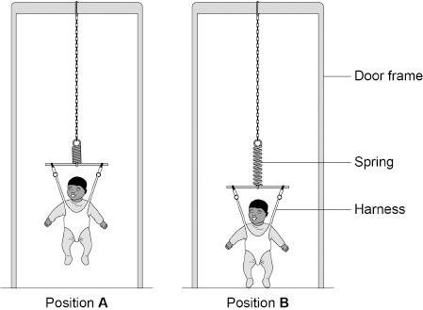
(a) The baby bouncer should not be used with babies that have a mass greater than 12 kg.
Suggest one reason why.
___________________________________________________________________
___________________________________________________________________
___________________________________________________________________
(1)
(b) In positions A and B the baby is stationary.
Describe the energy transfers as the baby moves from position A to position B.
___________________________________________________________________
___________________________________________________________________
___________________________________________________________________
___________________________________________________________________
___________________________________________________________________
___________________________________________________________________
(3)
(c) In one position the extension of the spring is 8.0 cm.
The elastic potential energy stored by the spring is 4.0 J.
Calculate the spring constant of the spring.
Use the Physics Equations Sheet.
___________________________________________________________________
___________________________________________________________________
___________________________________________________________________
___________________________________________________________________
___________________________________________________________________
___________________________________________________________________
___________________________________________________________________
Spring constant = ____________________ N/m
(4)
(Total 8 marks)
Q10.
Some cars have a lever that is used to apply the handbrake.
Figure 1 shows the handbrake lever in a car.
Figure 1
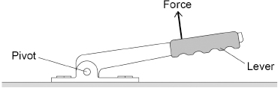
(a) The driver applies the force shown in Figure 1. The force produces a moment about the pivot.
How could the driver increase the moment about the pivot without increasing the size of the force?
___________________________________________________________________
___________________________________________________________________
(1)
The driver releases the handbrake.
Figure 2 shows how the velocity of the car changes during the first 5 seconds of a journey.
Figure 2
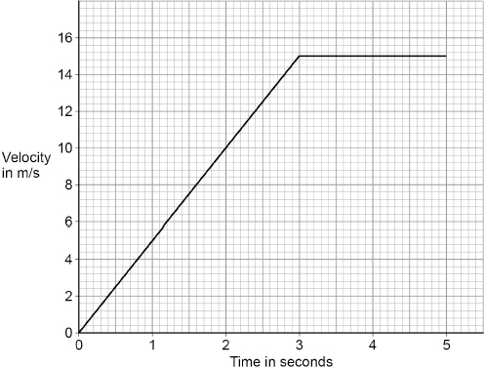
(b) After 3 seconds, the momentum of the car is 24 000 kg m/s.
Calculate the mass of the car.
Use the Physics Equations Sheet.
___________________________________________________________________
___________________________________________________________________
___________________________________________________________________
___________________________________________________________________
___________________________________________________________________
___________________________________________________________________
Mass = ____________________ kg
(4)
(c) Determine the distance travelled by the car during the first 5 seconds of the journey.
Use Figure 2.
___________________________________________________________________
___________________________________________________________________
___________________________________________________________________
___________________________________________________________________
___________________________________________________________________
Distance travelled by the car = ____________________ m
(3)
(d) In an emergency the driver needs to apply the brakes suddenly to stop the car quickly.
The driver of the car is distracted.
Explain why the distraction will increase the stopping distance.
___________________________________________________________________
___________________________________________________________________
___________________________________________________________________
___________________________________________________________________
___________________________________________________________________
___________________________________________________________________
(3)
(e) Explain why the temperature of the brakes increases as they are used.
___________________________________________________________________
___________________________________________________________________
___________________________________________________________________
___________________________________________________________________
___________________________________________________________________
(2)
(Total 13 marks)
Q11.
The figure below shows a girl doing an experiment to determine her power output by running to the top of some stairs.
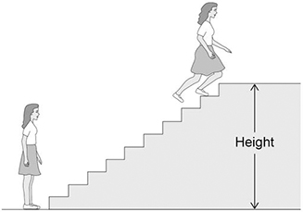
(a) The mass of the girl was 60.0 kg.
The height of the stairs was 175 cm.
The girl ran to the top of the stairs in 1.40 s.
gravitational field strength = 9.8 N/kg
Calculate the power output of the girl.
Use the Physics Equations Sheet.
___________________________________________________________________
___________________________________________________________________
___________________________________________________________________
___________________________________________________________________
___________________________________________________________________
___________________________________________________________________
___________________________________________________________________
Power = _______________ W
(5)
(b) The total power output of the girl was greater than the answer to part (a).
Suggest two reasons why.
1. _________________________________________________________________
___________________________________________________________________
2. _________________________________________________________________
___________________________________________________________________
(2)
(c) A boy took more than 1.40 s to run up the same stairs.
The power output of the boy was the same as the power output of the girl.
What conclusion can be made about the boy's mass?
Tick (✓) one box.

The boy's mass was greater than the girl's mass.
The boy's mass was lower than the girl's mass.
The boy's mass was the same as the girl's mass.
(1)
(Total 8 marks)
Q12.
The figure below shows a student launching a toy aeroplane.
To launch the aeroplane, the student pulls on it to stretch the spring and then releases it.
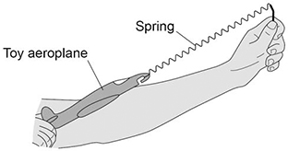
(a) Just before the toy aeroplane is released, the spring has an extension of 0.12 m.
mass of aeroplane = 0.020 kg
spring constant of the spring = 50 N/m
Calculate the maximum speed of the toy aeroplane just after it is launched.
Use the Physics Equations Sheet.
Give the unit.
___________________________________________________________________
___________________________________________________________________
___________________________________________________________________
___________________________________________________________________
___________________________________________________________________
___________________________________________________________________
___________________________________________________________________
___________________________________________________________________
___________________________________________________________________
___________________________________________________________________
Speed = __________ Unit __________
(6)
(b) Complete the sentence.
As the aeroplane moves upwards through the air there is a decrease
in the ____________________ energy of the aeroplane.
(1)
(c) Give one factor which would increase the distance the toy aeroplane travels horizontally before hitting the ground.
___________________________________________________________________
___________________________________________________________________
(1)
(Total 8 marks)

Mark schemes
Q1.
(a) chemical
1
kinetic
1
in this order only
(b) E_{k} = 0.5 × 80 × 12²
1
E_{k} = 5760 (J)
1
an answer of 5760 (J) scores 2 marks
(c) E = 0.040 × 480 × 50
1
E = 960 (J)
1
an answer of 960 (J) scores 2 marks
(d) increased
1
[7]
Q2.
(a) gravitational potential
1
kinetic
1
this order only
(b) E_{e} = 0.5 × 120 000 × 0.015²
1
E_{e} = 13.5 (J)
1
(c) E = 540 (J)
allow their answer from part (b) × 40
1
(d) E_{k} = 0.45 × 600
1
E_{k} = 270 (J)
1
(e) energy is transferred to the surroundings
1
[8]
Q3.
(a) kg
allow kilogram
1
°C
allow degrees Celsius
1
(b)
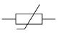
1
(c) P = 12² × 15
1
P = 2160 (W)
1
(d) The heating element in the kettle takes time to heat up
1
(e) Level 3: The method would lead to the production of a valid outcome. All key steps are identified and logically sequenced.
5−6
Level 2: The method would not necessarily lead to a valid outcome. Most steps are identified, but the method is not fully logically sequenced 3–4
3−4
Level 1: The method would not lead to a valid outcome. Some relevant steps are identified, but links are not made clear.
1−2
No relevant content
0
Indicative content:
• measure the mass of water using a balance
or
measure the volume of water using a measuring cylinder
• measure the initial temperature of the water
• pour the water into the kettle
• put temperature probe in the water
or
put a thermometer in the water
• switch kettle on
• record temperature
• measure time with a stopclock
• use an interval of 5 seconds
(f) Δϴ = 80 (°C)
1
E = 0.50 × 4200 × 80
allow E = 0.50 × 4200 × their value of Δϴ
1
E = 168 000 (J)
allow an answer consistent with their value of Δϴ
1
(g) m = 0.005 (kg)
1
E = 0.005 × 2 260 000
this mark may score if m is not/incorrectly converted
1
E = 11 300 (J)
allow an answer consistent with their value of m
1
[18]
Q4.
(a) the friction is decreased
1
(b) E_{p} = 62.5 × 9.8 × 16.0
1
E _{p} = 9800 (J)
1
(c) E_{k} = 0.5 × 62.5 × 12²
1
E_{k} = 4500 (J)
1
(d) Any two from:
• speed (at bottom of slide)
• friction (between sled and ground)
allow mass/weight of rider (and sled)
allow surface type
• air resistance
2
[7]
Q5.
(a) gravitational potential
this order only
1
kinetic
1
(b) kinetic energy = 0.5 × mass × speed²
or
E_{k} = ½mv²
1
(c) 5040 = 0.5 × m × 12²
1
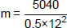
1
m = 70 (kg)
1
(d) the thermal energy increases.
1
[7]
Q6.
(a) (i) kinetic (energy)
allow gravitational potential (energy) / gpe
movement is insufficient
1
(ii) dissipates into the surroundings
allow warms up the surroundings / air / motor
accept lost to the surroundings
accept lost as heat
ignore reference to sound
it is lost is insufficient
1
(b) energy (required) increases with load
accept positive correlation
do not accept (directly) proportional
1
further amplification eg increases slowly at first (or up to 4 / 5 N),
then increases rapidly
simply quoting figures is insufficient
an answer that only describes the shape
of the line gains no marks
1
(c) (i) E = P × t
2880
accept £28.80 for all 3 marks
an answer £2880 gains 2 marks
allow 1 mark for obtaining 48 h or converting to kW
allow 2 marks for correct substitution
ie 4 × 48 × 15
note: this substitution may be shown as two steps
an answer 2 880 000 gains 2 marks
an answer £4.80 / 480 gains 2 marks
an answer of 192 (ie calculation of energy without subsequent calculation of cost) gains 1 mark)
3
(ii) any sensible suggestion eg
conserves fossil fuels
less (fossil) fuels burned
less pollutant gas (produced)
accept a named pollutant gas
less greenhouse gas (produced)
saves energy is insufficient
1
[8]
Q7.
(a) uniform acceleration
allow constant / steady acceleration
allow velocity / speed increasing at a constant rate
ignore reference to direction
acceleration scores 1 mark
or
velocity / speed is increasing scores 1 mark
do not accept acceleration increases
2
(b) up(wards)
1
(c) a group of objects that interact
1
(d) velocity just after bounce is less than just before bounce
allow velocity is less / decreases
velocity decreases to zero − on its own scores zero
or
the height at the top of the bounce is less than the height from which it was dropped
1
so the ball has lost energy
1
correct reference to (loss of) ke or (reduced) gpe
1
total energy of ball and Earth / ground is constant
allow ‘a system’ for ball and Earth
allow energy is conserved
1
[8]
Q8.
(a) gravitational potential
1
kinetic
1
chemical
1
(b) flying drones may damage aircraft
or
falling drones may injure people
or
damage buildings / vehicles
allow any sensible suggestion of a hazard caused by a flying / falling drone
1
(c) energy transferred = power × time
allow E = Pt
1
(d) t = 25 × 60 = 1500 (s)
1
E = 65 × 1500
1
E = 97 500 (J)
an answer of 97 500 (J) scores 3 marks
allow 2 marks for an answer of 1625 (J)
1
[8]
Q9.
(a) spring may become permanently extended
ignore reference to limit of proportionality
allow the harness / spring / chain may break
or
extension of the spring may be too great (so the baby's feet are always on the floor)
ignore baby may be injured / harmed / may hit doorframe
1
(b) (in position A) the baby has gravitational potential energy
allow E_{p} for gravitational potential energy
1
(as the baby moves down this) is transferred to kinetic energy
allow E_{k} for kinetic energy
(of the baby) and / then elastic potential energy (of the spring)
allow E_{e} for elastic potential energy
1
(in position B) all the energy is elastic potential energy
ignore energy dissipated to the surroundings
1
(c) e = 0.080 (m)
1
4.0 = ½ × k × 0.080²
allow a correct substitution using an incorrectly / not converted value of e
1
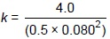
allow a correct rearrangement using an incorrectly / not converted value of e
1
k = 1250 (N/m)
allow an answer consistent with their value of e
1
[8]
Q10.
(a) apply the force further away from the pivot
do not allow increase the length of the lever
1
(b) v = 15 (m/s)
1
24 000 = m × 15
allow a value of v = 14.5 (m/s)
1
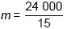
1
m = 1600 (kg)
1
(c) distance travelled during first 3 seconds = 22.5 (m)
1
distance travelled during last 2 seconds = 30 (m)
1
total distance = 52.5 (m)
allow 53 (m)
allow 1 mark for the correct addition of their calculated distances
allow a maximum of 2 marks for total distance = 50.75 (m) if velocity used = 14.5 (m/s)
1
(d) stopping distance includes thinking distance
allow stopping distance = braking distance + thinking distance
1
there is an additional time before the driver applies the brakes.
allow the driver's reaction time will increase (due to the distraction)
1
(so) the thinking distance will increase
1
(e) work is done due to friction (in the brakes)
ignore friction alone
1
(causing) an increase in the internal / thermal energy (of the brakes)
1
[13]
Q11.
(a) h = 1.75 (m)
1
E_{p} = 60 × 9.8 × 1.75
allow a correct substitution using an incorrectly / not converted value of h
1
E_{p} = 1029 (J)
allow a correct calculation using an incorrectly / not converted value of h
1
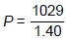
allow a correct substitution using their calculated value of E_{p}
1
P = 735 (W)
allow an answer consistent with their value for E_{p}
1
(b) girl increases her kinetic energy (as well as increasing her gravitational potential energy)
1
some energy is wasted in her muscles
or
some energy transferred as thermal energy (to surroundings)
allow some energy transferred due to air resistance
ignore unqualified references to friction
ignore references to sound
1
(c) the boy’s mass was greater than the girl’s mass
1
[8]
Q12.
(a) E_{e} = 0.5 × 50 × 0.12²
1
E_{e} = 0.36 (J)
1
0.36 = 0.5 × 0.020 × v²
allow a correct substitution of their calculated value of E_{e}
1
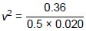
allow a correct rearrangement of their calculated value of E_{e}
or
v² = 36
1
speed = 6.0
allow an answer consistent with their calculated value of E_{e}
1
m/s
or
metres/second
1
Alternative approach:
(F = ke)
(F = 50 × 0.12)
(maximum) F = 6.0 (N) (1)
(F = ma)
(6.0 = 0.020 × a)
(maximum) a = 300 (m/s²) (1)
mean a = 150 (m/s²) (1)
(v² − u² = 2as)
v² = 2 × 150 × 0.12 (1)
or
v² = 36
v = 6.0 (1)
m/s (1)
or
metres/second
(b) kinetic
1
(c) increasing the extension of the spring
or
more elastic potential energy
or
increase the angle of release (to the horizontal by a small amount)
allow other factors that would increase the horizontal distance travelled eg a tail-wind
ignore factors without a change specified e.g. extension unqualified would not score
ignore changing the spring or changes to the toy aeroplane
1
[8]

